**OverTheWire Bandit – Level 0 to Level 1 Writeup**

**Introduction**: This writeup documents my experience solving Levels 0 to 1 of the OverTheWire Bandit challenge, a CTF-style game focused on learning about security concepts.

**Author**: Misha Jain

**Date**: October 19, 2023

**Tools Used:**

Terminal (SSH client)

**Challenge Description:**

Level 0 to Level 1 of Bandit involves connecting to a remote server via SSH and retrieving the password located in the home directory of the server.

**Enumeration:**

For Level 0, we use the following credentials:

Host: bandit.labs.overthewire.org

Port: 2220

Username: bandit0

Password: bandit0

For Level 1, we need to connect using the password obtained from Level 0.

**Exploitation – Level 0:**

To connect to the server for Level 0 using SSH, we can use the provided credentials:

ssh bandit0@bandit.labs.overthewire.org -p 2220

After entering the password (which is also "bandit0"), we are granted access to the server.

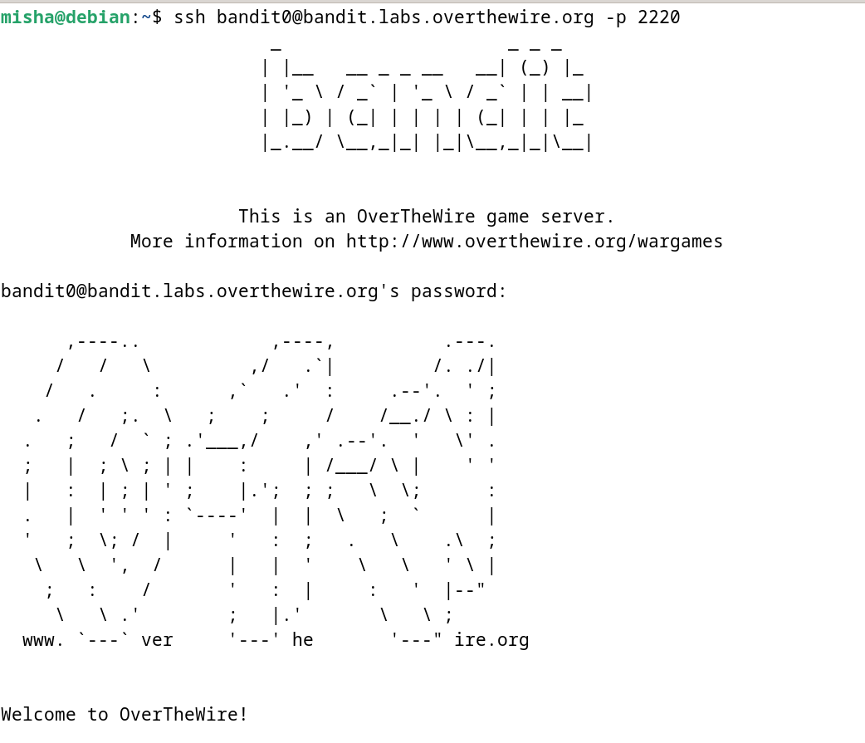

**Password Retrieval – Level 0:**

To retrieve the password, we can simply use the cat command to read the contents of the "readme" file located in the home directory:

cat readme

This command will display the contents of the "readme" file, which contains the password for Level 1.

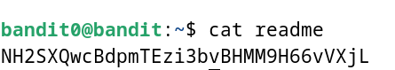

**Password – Level 1:**

The password for Level 1 is: NH2SXQwcBdpmTEzi3bvBHMM9H66vVXjL

**Exploitation – Level 1:**

Now that we have the password for Level 1, we can connect to the server for Level 1 using SSH:

ssh bandit1@bandit.labs.overthewire.org -p 2220

Use the Level 1 password, which is NH2SXQwcBdpmTEzi3bvBHMM9H66vVXjL, to gain access.

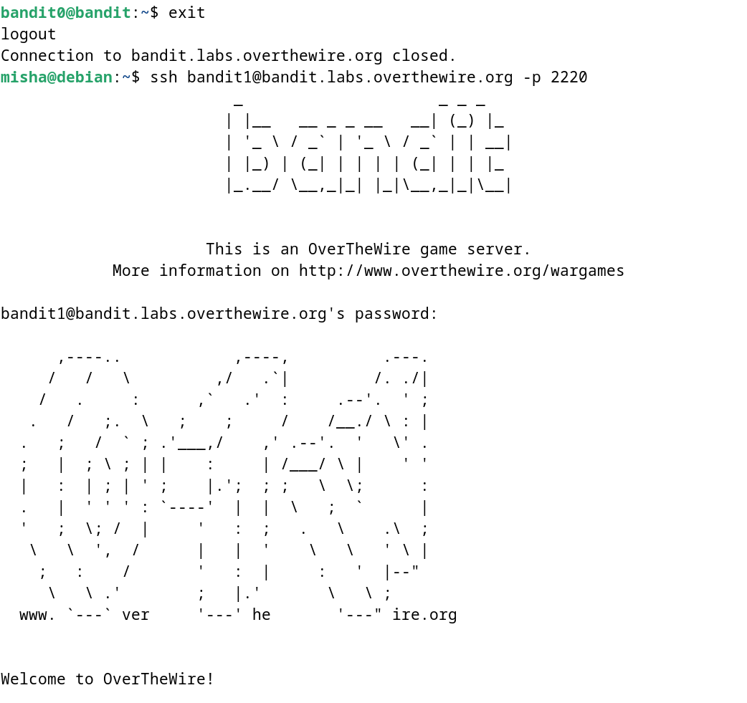

**Lessons Learned:** Level 0 introduced us to SSH and basic Linux command usage. We continued using the cat command to read the "readme" file for Level 1.

**Conclusion:**

Levels 0 to 1 of the OverTheWire Bandit challenge build upon the basic knowledge gained in Level 0, providing a smooth progression for beginners to further explore security concepts and Linux command-line skills.